CSE 219 – Fall 2013 – Midterm Exam – Group 1 - Solutions

Monday, 10/21/2013

Name: First Last

Student ID # _________________________________

- Please show your ID when requested.
- Please leave at least one seat between yourself and the person next to you.
- Use a #2 Pencil to fill in the appropriate bubble on your answer sheet.
- Fill in one answer per question No books, notes, or electronic equipment can be used during the exam.
- For all questions, select the best answer from the choices provided
- Any CHEATING will result in an F as well as being written-up on academic dishonesty.

FIRST:
- Write and fill in the bubbles for your full name on the answer sheet
- Write and fill in the bubbles for your ID Number on the answer sheet
- DO NOT FILL IN YOUR DATE OF BIRTH
- Under the BIRTH DATE Table, go to the Left Column of DAY, you'll see only 4 choices (0-3). If you have Exam Version A, fill in 0, if you have Exam Version B, fill in 1.

ATTENTION: Make sure your exam has all 50 questions.

Question 1

In HW 3 we defined the MahjongSolitairePanel class. For the test method defined below, which line would result in a syntax error?

public static void test( MahjongSolitairePanel canvas)

{

Object o = canvas; // A

JPanel p = canvas; // B

Container c = canvas; // C

JFrame f = canvas; // D

canvas = canvas; // E

}

Question 2
Which of the following is not one of the four states of a thread in Java’s multithreaded model?
- Blocked
- Dead
- New
- Runnable
- Running

Question 3
What is used to call a constructor in the same class during a class’ construction?
- new
- super.
- super( )
- this.
- this( )

Question 4
What Java API method did we use to request exclusive access to data for a given thread?
- finally
- lock
- notify
- request
- reserve

Question 5
The _________________ only cares about an object’s actual type.
- Java Compiler
- Java Virtual Machine (JVM)
- Subversion Client
- Thread Scheduler
- JDK

Question 6
The actual type of an object refers to the type the object was _______________ as.
- Assigned
- Cast
- Declared
- Inherited
- Instantiated

Question 7
The apparent type of an object refers to the type the object was _______________ as.
- Assigned
- Cast
- Constructed
- Declared
- Inherited

Question 8
What Object Oriented Programming feature lets methods defined in frameworks call custom methods defined years later in applications?
- enums
- generics
- instance variables
- polymorphism
- static variables

Question 9
What Java API class did we use to read player data from a file into memory in HW 3?
- BufferedReader
- BufferedInputStream
- ByteArrayInputStream
- DataInputStream
- ObjectInputStream

Question 10
What Java API class did we use to read player data from a byte array in memory into our objects?
- BufferedReader
- ByteArrayInputStream
- DataInputStream
- FileReader
- ObjectInputStream

Question 11
What term is used in Software Engineering to describe how well a program will can accommodate change so as to add future functionality?
- Extensibility
- Flexibility
- Regression
- Robustness
- Scalability

Question 12
What term is used to describe the scenario where multiple threads have reserved data and are waiting for other threads to release their own data?
- Daemon
- Deadlock
- Race Condition
- Volatility
- Zombie

Question 13
Below is a portion of the EN.xml file from HW 2.

<property_options name="LETTER_OPTIONS">

What type of XML construct is name?
- attribute
- element
- schema
- tag
- value

Question 14
Which one of the following statements below is true?
- An abstract class may not implement an interface
- An abstract class may be instantiated.
- An interface may have a static variable
- A variable may have an abstract class as its apparent type
- A variable may have an abstract class as its actual type

Question 15
What word best describes Java’s Map family, of which both HashMap and TreeMap are members?
- Acyclic Graph
- Dictionary
- Graph
- Heap
- Stack

Below are the definitions for the Camera and Vec classes which should be used to answer the questions that follow:

public class Camera
{
public Vec position = new Vec();
public Vec lookAtVector = new Vec();
public Vec upVector = new Vec();
}

public class Vec
{
public int x = 0;
public int y = 0;
public int z = 0;
}

Question 16
Using the 32-bit version of Java, how many bytes would be allocated onto the heap in total when a Camera object is constructed inside a method and assigned to a local variable?
- 16
- 24
- 36
- 48
- 96

Question 17
Using the 64-bit version of Java, how many bytes would be allocated onto the global region of memory in total when the Camera class’ position instance variable is constructed?
- 0
- 4
- 8
- 20
- 40

Question 18
Which of the following constructs below cannot override methods?
- Abstract Classes
- Concrete Classes
- Interfaces
- All of the above
- None of the above
The code on the right compiles and executes without error. Note that there are 6 lines printed.
Camera c = new Camera();

Vec pos = c.position;
Vec up = c.upVector;
up.x = 2;
up = pos;
c.lookAtVector = pos;
pos = new Vec();
pos.x = 3;

Vec lav = c.lookAtVector;
c.lookAtVector = c.upVector;
lav.x = 4;
up.x = 5;

c.lookAtVector = new Vec();
c.position.x = 6;

System.out.println(c.position.x);
System.out.println(pos.x);
System.out.println(c.lookAtVector.x);
System.out.println(lav.x);
System.out.println(c.upVector.x);
System.out.println(up.x);
Question 19
When executed, what would the 1st line of output be?
- 0
- 2
- 3
- 5
- 6

Question 20
When executed, what would the 2nd line of output be?
- 2
- 3
- 4
- 5
- 6

Question 21
When executed, what would the 3rd line of output be?
- 0
- 3
- 4
- 5
- 6

Question 22
When executed, what would the 4th line of output be?
- 0
- 2
- 3
- 4
- 6

Question 23
When executed, what would the 5th line of output be?
- 0
- 1
- 2
- 3
- 6
Question 24
When executed, what would the 6th line of output be?
- 0
- 1
- 2
- 3
- 6

The code on the right compiles and executes without error. Note that there are 3 lines printed.
public class Ref
{
public static void main(
String[] args)
{
Vec v = new Vec();
v.x = 5;
int a = v.x;
a++;
reset(v, v, a);
System.out.println(a);
System.out.println(v.x);
System.out.println(v.y);
}

public static void reset(
Vec v1, Vec v2, int x)
{
v1 = new Vec();
v1.x = 8;
v2.y = 9;
x = 2;
}
}
Question 25
When executed, what would the 1st line of output be?
- 2
- 5
- 6
- 8
- 9

Question 26
When executed, what would the 2nd line of output be?
- 2
- 5
- 6
- 8
- 9

Question 27
When executed, what would the 3rd line of output be?
- 2
- 5
- 6
- 8
- 9

Question 28
Which of the following Swing controls has an addHyperlinkListener method?
- JButton
- JEditorPane
- JOptionPane
- JPanel
- JTextField

Question 29
What Java API class stores the full contents of an HTML page in a tree?
- Document
- File
- Object
- Schema
- TreeMap

Question 30
The code below compiles and runs without error and might print out text that looks something like java.lang.Object@10b28f30.

Object obj = new Object();
System.out.println(obj);

What does 10b28f30 refer to?
- obj’s hash code
- obj’s JAR
- obj’s memory address
- obj’s package
- obj’s reference id number

Below are the class definitions for the City, NYCity, LICity, and BrookhavenCity classes, which all compile and run without error. Note these are used for the questions on the following page.

public class City
{
public String city;
public String state;

public void update(String initCity)
{
city = "Unknown";
state = "XX";
}

public String toString()
{
return state;
}
}

public class NYCity extends City
{
public void update(
String initCity)
{
city = initCity;
state = "NY";
}
}
public class CACity extends City
{
public String toString()
{
return city;
}
}

public class BrookhavenVillage extends LICity
{
public void update(String initCity)
{
super.update(initCity);
state = "LI";
}
}
public class LICity extends NYCity { }
The code below compiles and executes without error. Note that there are 4 lines printed.
public static void main(String[] args)
{
City c = new City();
foo(c, "Lake Placid");
CACity ca = new CACity();
foo(ca, "Eureka");
LICity lic = new LICity();
foo(lic, "Sea Cliff");
BrookhavenVillage bv = new BrookhavenVillage();
foo(bv, "Port Jefferson");
}

public static void foo(City city, String name)
{
city.update(name);
System.out.println(city);
}

Question 31
When executed, what would the 1st line of output be?
- CA
- Lake Placid
- NY
- Unknown
- XX

Question 32
When executed, what would the 2nd line of output be?
- CA
- Eureka
- NY
- Unknown
- XX

Question 33
When executed, what would the 3rd line of output be?
- CA
- LI
- NY
- XX
- Unknown

Question 34
When executed, what would the 4th line of output be?
- CA
- LI
- NY
- XX
- Unknown

Question 35
What is the first stage in the Software Development Lifecycle?
- Deployment
- Design Review
- Profiling
- Requirements Analysis
- Software Design

Question 36
Java’s Thread class has a constructor that takes an argument of what apparent type?
- JFrame
- Object
- Runnable
- Task
- Timer

Question 37
When describing how we wish to develop software that is easy to use, we said that it should be easy to use for both the end user and who else?
- Hackers
- Other programmers
- Reverse Engineers
- The Compiler
- The JVM

Question 38
What method did the Mini Game Framework call on our canvas each frame after updating the game state?
- paint
- paintComponent
- repaint
- revalidate
- validate

Question 39
What is the type of the only argument passed to the actionPerformed method?
- Action
- ActionCommand
- ActionEvent
- ActionListener
- String

Question 40
Which of the following statements below is false?
- A non-static method may directly reference a static constant from the same class.
- A non-static method may directly reference a static method from the same class.
- A non-static method may directly reference a static variable from the same class.
- A static method may directly reference (without a ‘.’) a static variable from the same class.
- A static method may directly reference a non-static variable from the same class.

Question 41
What HTML element is used to specify an item in an ordered list?
- <i>
- <li>
- <p>
- <span>
- <tr>

Question 42
What can be found in both an abstract class and an interface?
- abstract methods
- concrete methods
- inner class
- instance variables
- static variables

Question 43
Assuming Student is a child class of Person, which line of code below produces a compiler error?

Person p = new Person();
Student s = new Student();
p = new Student(); // A)
p = (Person)new Student(); // B)
p = (Student)new Student(); // C)
s = (Person)new Person(); // D)
s = (Student)new Person(); // E)

Question 44
When setting up SVN, one must specify where all the committed data will ultimately be stored. What is this storage location called?
- Commit Cell
- CVS
- Repository
- Root Cellar
- Trunk

Question 45

When multiple threads are simultaneously in the Runnable state, who decides which one should actually get to

execute on the CPU?

Java’s Thread Scheduler
- Runnable interface
- ThreadDeath class
- Thread class
- None of the above, it’s completely random

Question 46
When using an IDE’s debugger, if the debugger was paused on a print statement (System.out.println…) and you were to then press the “Step Over” button, what would the debugger do?

Skip execution of the print statement and pause on the next line of code

Skip execution of the print statement and all following statements until a breakpoint is reached
- Step into the execution of the println method and freeze.

Execute the print statement and pause on the next line of code

Execute the print statement and all following statements until a breakpoint is reached

Question 47
What word is used in software development to describe how well a Web application of some kind will meet response time requirements when its workload is increased from ten clients up to thousands of clients?
- Efficiency
- Extensibility
- Reliability
- Scalability
- Usability

Question 48

For the GUI displayed below, what layout manager is being used for the JFrame?
- BorderLayout
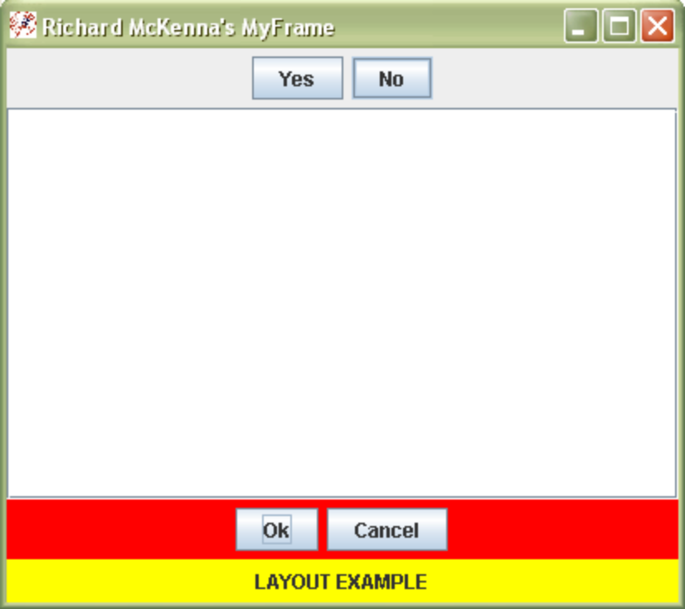
- FlowLayout
- GridLayout
- GridBagLayout
- Null Layout

Question 49
How many tiles are there in the Mahjong Solitaire game we made in HW 3?
- 100
- 124
- 136
- 144
- 150

Question 50
In Candy Crush Saga, how does one get a striped special candy?
- 3 in a row
- 4 in a row
- 5 in a row
- L-shaped match
- T-shaped match

